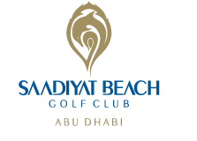
BBG Abu Dhabi Corporate Golf Day Booking Form
Thursday 14th October 2021 Saadiyat Beach Golf Club, Abu Dhabi – Tee Off Times 11.30am-1pm

Player Name | Company Name | Mobile Number | Email Address | Handicap | Shirt Size
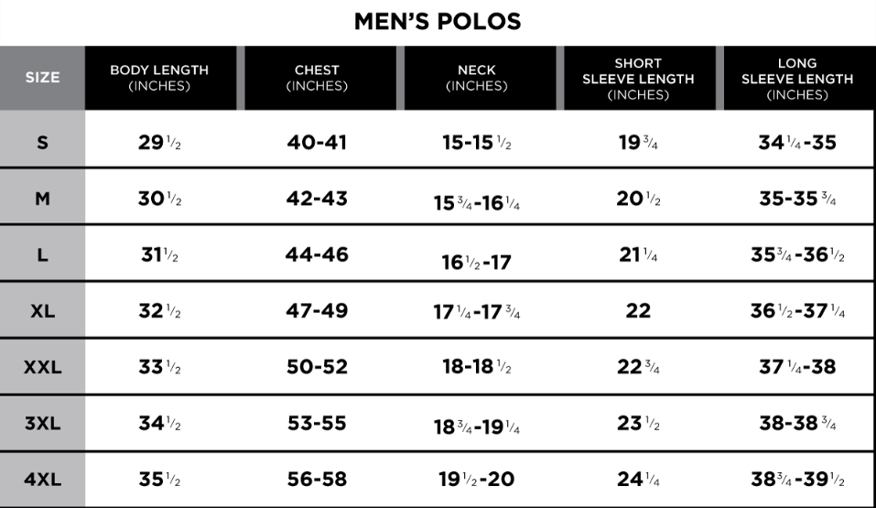
Partnership Opportunities:
Would you like to sponsor a hole?
Would you like to provide a raffle prize?
Contact Sinead at office@bbgauh01.ae to discuss opportunities for your company.

Cancellation policy:
Payment must be made by 6th October 2021 in order to confirm your players.
Payment can be made by bank transfer or over the phone using credit card. Liaise with Sinead at office@bbgauh01.ae or 0566650582 to confirm.

With thanks to Event Sponsors:

